Topics: Confidence Intervals

- For each of the following statements, indicate whether it is True/False. If false, explain why.

- The sample size of the survey should at least be a fixed percentage of the population size in order to produce representative results.

Answer: - False.
A survey's sample size should not be determined by a fixed percentage of the population. Sample size is influenced by many factors, including precision, variability, confidence, and cost/time constraints. In general, larger sample sizes result in more precise estimates and higher levels of confidence, but they also increase survey costs and time. Therefore, rather than a fixed percentage of the population size, the sample size should be determined by carefully considering these factors.

- The sampling frame is a list of every item that appears in a survey sample, including those that did not respond to questions.

Answer: - False.
The sampling frame is a list of all the items in the population from which the sample is drawn. It is not a list of items in the sample itself, whether they responded to the survey or not.

- Larger surveys convey a more accurate impression of the population than smaller surveys.

Answer: - True.
larger surveys can convey a more accurate impression of the population than smaller surveys. This is because larger surveys have a larger sample size, which can reduce sampling error and increase the representativeness of the sample.

- PC Magazine asked all of its readers to participate in a survey of their satisfaction with different brands of electronics. In the 2004 survey, which was included in an issue of the magazine that year, more than 9000 readers rated the products on a scale from 1 to 10. The magazine reported that the average rating assigned by 225 readers to a Kodak compact digital camera was 7.5. For this product, identify the following:

- The population
Answer: - p=x/n=225/9000=0.025

- The parameter of interest
Answer: - sample size, average, scale

- The sampling frames
Answer: - 9000

- The sample size
Answer: - 225

- The sampling design
Answer: - The sampling design used in this case is convenience sampling, which involved asking PC Magazine readers to participate.

- Any potential sources of bias or other problems with the survey or sample
Answer: - Selection of the readers, selection of the issue which will contain the survey

- For each of the following statements, indicate whether it is True/False. If false, explain why.

- If the 95% confidence interval for the average purchase of customers at a department store is $50 to $110, then $100 is a plausible value for the population mean at this level of confidence.

Answer: - True.
Since $100 is within the interval $50 to $110, it is a plausible value for the population mean at this level of confidence. However, we cannot say with certainty that the population mean is exactly $100, as it is only one of the many plausible values that could fall within the confidence interval.

- If the 95% confidence interval for the number of moviegoers who purchase concessions is 30% to 45%, this means that fewer than half of all moviegoers purchase concessions.

Answer: - False.
The confidence interval only provides information about the range of plausible values for the true proportion, and it does not allow us to make definitive statements about the proportion itself.

- The 95% Confidence-Interval for μ only applies if the sample data are nearly normally distributed.
Answer: - True
The 95% confidence interval for the average purchase of customers at a department store is $50 to $110. Which means that there is a 95% chance that the population mean will fall between $50 and $110. Hence, as $100 falls between $50 and $110, it is a plausible value for the population mean at this confidence level. II. If the 95% confidence interval for the number of moviegoers who purchase concessions is 30% to 45%, this means that fewer than half of all moviegoers purchase concessions. Answer: TRUE Reason: The 95% confidence interval for the number of moviegoers who purchase concessions is 30% to 45%, this means that there is a 95% chance that only 30 to 45 % of moviegoers purchase concessions, which is less than 50%. Hence, we can infer that fewer than half of all the moviegoers purchase concessions. III. The 95% Confidence-Interval for μ only applies if the sample data are nearly normally distributed.

- What are the chances that 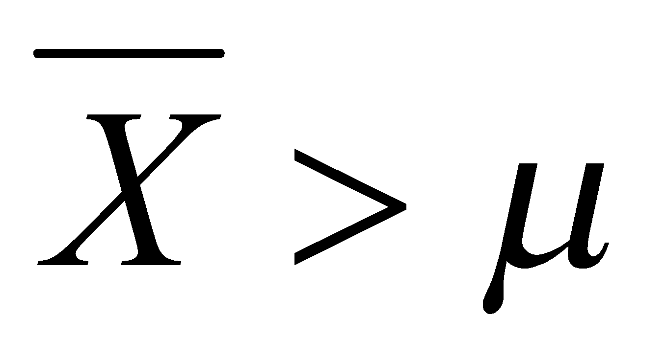?

- ¼
- ½
- ¾
- 1
Answer: - D. 1 (Mean of Sample means is equal to population mean)

- In January 2005, a company that monitors Internet traffic (WebSideStory) reported that its sampling revealed that the Mozilla Firefox browser launched in 2004 had grabbed a 4.6% share of the market.

- If the sample were based on 2,000 users, could Microsoft conclude that Mozilla has a less than 5% share of the market?
Answer: - No

- WebSideStory claims that its sample includes all the daily Internet users. If that’s the case, then can Microsoft conclude that Mozilla has a less than 5% share of the market?
Answer: - Yes

- A book publisher monitors the size of shipments of its textbooks to university bookstores. For a sample of texts used at various schools, the 95% confidence interval for the size of the shipment was 250 ± 45 books. Which, if any, of the following interpretations of this interval are correct?

- All shipments are between 205 and 295 books. - This interpretation is not correct. The confidence interval provides an estimate of the range in which the true population mean is likely to fall, not the range for individual shipments.

- 95% of shipments are between 205 and 295 books. - This interpretation is not correct. The confidence interval provides information about the likely range for the population mean, not for individual shipments. It does not make a statement about a specific percentage of shipments falling within this range.

- The procedure that produced this interval generates ranges that hold the population mean for 95% of samples. - This interpretation is correct. The 95% confidence interval implies that if we were to repeat the sampling process many times and construct a confidence interval for each sample, approximately 95% of these intervals would contain the true population mean.

- If we get another sample, then we can be 95% sure that the mean of this second sample is between 205 and 295. - This interpretation is not correct. The confidence interval is specifically about the population mean, not the mean of a second sample. It is about the range that likely contains the true population mean, not the range for individual sample means.

- We can be 95% confident that the range 160 to 340 holds the population mean. - This interpretation is not correct. The confidence interval provided in the question is 250 ± 45 books, which corresponds to the range (205, 295). It does not include the range 160 to 340.

- Which is shorter: a 95% z-interval or a 95% t-interval for μ if we know that σ =s?

- The z-interval is shorter
- The t-interval is shorter
- Both are equal
- We cannot say
Answer:- When calculating confidence intervals for the mean (μ) using a known population standard deviation (σ = s), a z-interval and a t-interval can be used.

In this case, since the population standard deviation (σ) is known, we can use the z-distribution to calculate the confidence interval. The z-interval assumes a normal distribution.

On the other hand, the t-interval is used when the population standard deviation (σ) is unknown, and we estimate it using the sample standard deviation (s). The t-interval takes into account the variability introduced by the estimation of the standard deviation and uses the t-distribution.

When comparing a z-interval and a t-interval with the same confidence level (e.g., 95% confidence), the t-interval will be shorter than the z-interval. This is because the t-distribution has fatter tails compared to the z-distribution. The fatter tails account for the additional uncertainty introduced when estimating the standard deviation from the sample.
Therefore, the correct answer is B. The t-interval is shorter.

Questions 8 and 9 are based on the following: To prepare a report on the economy, analysts need to estimate the percentage of businesses that plan to hire additional employees in the next 60 days.

- How many randomly selected employers (minimum number) must we contact in order to guarantee a margin of error of no more than 4% (at 95% confidence)?

- 600
- 400
- 550
- 1000

Answer: - The minimum sample size required to estimate the population proportion with a margin of error no more than 4% can be calculated using the formula:
n = [z^2 p (1-p)] / E^2
where:
- n is the sample size
- z is the z-score corresponding to the desired level of confidence (95% confidence level corresponds to a z-score of 1.96)
- p is the estimate of the population proportion (we can use 0.5 for maximum variability)
- E is the maximum margin of error, which is 0.04 (4%)
Substituting the values, we get:
n = [1.96^2 0.5 (1-0.5)] / 0.04^2 n = 600.25
Rounding up to the nearest whole number, the minimum sample size required is 601.
Therefore, A. 600 is the correct answer.

- Suppose we want the above margin of error to be based on a 98% confidence level. What sample size (minimum) must we now use?

- 1000
- 757
- 848
- 543

Answer: - To determine the minimum sample size needed to estimate the percentage of businesses that plan to hire additional employees in the next 60 days with a margin of error based on a 98% confidence level, we need to use the following formula:
n = (z*σ/E)^2
Where:
- n is the sample size
- z is the z-score corresponding to the desired confidence level (98% confidence level corresponds to a z-score of 2.33)
- σ is the standard deviation of the population (unknown)
- E is the maximum desired margin of error (unknown)
Since the population standard deviation is unknown, we can use a conservative estimate and assume that the population proportion is 0.5, which gives us the maximum variability and therefore requires the largest sample size.
Assuming a maximum desired margin of error of 5%, we can calculate the minimum sample size needed as follows:
n = (2.33*0.5/0.05)^2 = 848.77
Rounding up to the nearest whole number, we get a minimum sample size of 849.
Therefore, the answer is option C: 848.

